SAMPLE DIET FOR JO

Breakfast Afternoon snack
2 slices of white bread toast with honey Cereal bar
Apple 1 cup of coffee
1 cup of coffee

Morning snack Dinner
1 cup of coffee 15 cm diameter thin chicken pizza
Mixed salad
Lunch 2 slices of garlic bread
Low kilojoules cup of soup 2 large glasses of wine
3 crisp bread with cheese and vegemite
1 cup of coffee

Total kilojoules = 6720kJ

Jo’s Diet

1. Review Jo’s diet and explain three (3) important criticisms of the suitability of this diet during pregnancy. (3 x 2 = 6 marks)

(i) Chicken pizza – the meat in the pizza may be undercooked with the potential

source of bacteria like E. coli and Salmonella, which may pass through blood to

developing foetus.

NOTE: Immune System not covered until YR 12 work in last 5 weeks of Term 4

(ii) Inadequate amount of fruits and vegetables – which are essential to replenish the

vitamins and minerals.

Deficiency of proteins – no serves of milk, yohurt, cheeses and eggs.

Low in energy – only 6720 KJ of energy, a pregnant woman requires 8,100 to

(iii) 10,900 KJ of energy for herself and unborn baby.

Diet likely to be low in iron as no red meat is included – vegetables rich in iron are

not included. Iron needed for increased blood production during pregnancy.

Diet likely low in folate – which is needed to prevent neural tube defects of foetus.
Sex Selection

2. You will have to explain fully to Jo how she might determine the gender of her second child prenatally. Answer the questions below which relate to this issue.

(i) How early in pregnancy can Jo find out the gender of her embryo/ foetus? Name the test involved and briefly describe the test and how it can determine the gender of her unborn baby. (4 marks)

As early as 7 weeks (more reliable slightly later) x 1

DNA Testing (gender prediction test) x 1

Obtain ~ 50-100mL of urine; or finger-prick maternal blood sample x 1

Urine test used to look for Y chromosome in strands of DNA excreted in the urine;

or maternal bloodstream contains free foetal DNA which also may contain Y

chromosomes. Presence indicates XY (a boy) or absence indicates XX (a girl) x1

- Name one other test available later in pregnancy. Briefly describe this test.
(2 marks)
Chorionic Villus Sampling (CVS) usually 10th – 14th week* x1

A sample of placental tissue is taken, a fragment of chorionic villi, either through a

needle that passes into the abdomen or in some cases through a fine tube that

passing into the vagina (a Transvaginal CVS) x 1 OR

Amniocentesis usually 15th – 18th week* x 1

A sample of amniotic fluid is taken ~ 20mL, a pocket of amniotic fluid (a safe

distance from both the unborn baby and placenta) is identified and a long, thin ,

hollow needle is inserted through the abdominal wall into the pocket of amniotic

fluid x1

Ultrasound usually ~ week 20 (however also used to guide needles/tubes in CVS

and Amniocentesis) x1 OR
Ultrasound sends high-frequency soundwaves through the uterus. These bounce off

the unborn baby and the echoes are turned into an image on a screen. The

sonorgrapher may provide printouts of the image for parents to be to keep x1

(iii) What action can Jo take if the tests show her unborn baby to be a girl? Discuss her options? (2 marks)

Termination of pregnancy, provided legal constraints and stage of pregnancy x1

Continuing with pregnancy and accepting the birth of another girl x1

Risk Factors of Increased Maternal Age

3. At 36 years of age Jo is considered an ‘older’ mother. In western societies this trend of having children at a later age is quite common. Explain two (2) possible health consequences of pregnancy at an older age to herself and the unborn baby.

To her (any 2 only) (2marks)

Reduced fertility x1 High blood pressure x1

Higher risk of miscarriage x1 Increased chance of caesarean x1

Induced labour x1 Forceps or ventouse delivery x1

To her unborn child (any 2 only) (2 marks)

Increased chance of genetic disorder e.g. Down’s Syndrome x1

Increased foetal distress x1 low birth weight x1

premature delivery x1 Increased placental abruption x1

(placenta prematurely separates from the uterine wall)

4. Due to these possible health consequences at increased maternal age in pregnancy, state one genetic test that Jo (and her doctor) may wish to consider. What benefit will such testing have? (3 marks)

Test: Karyotyping, Chorionic Villus Sampling, Amniocentesis, and Maternal

Serum Screening (blood test) x1 ANY 1 ONLY

Benefits: Will confirm if unborn baby has a genetic concern or not x1

Enable timely treatment (if available) of a condition before or after birth x1

Give parents-to-be the choice to terminate or continue with pregnancy x1

Prepare parents-to-be psychologically, socially, financially and medically for a baby

with health or disability problems x1 ANY 3 ONLY

Ethical Issues

5. Describe two (2) ethical issues Jo must consider when deciding to have any prenatal testing done. (4 marks)

Increased risk to pregnancy – getting samples from foetus, such as in CVS and

Amniocentesis x1

Prior knowledge of any birth defect may cause greater stress on the mother-to-

be x1

Prior knowledge of any birth defect may not be helpful, sometimes there is no

treatment until the baby is born x1

May lead to wanting choosing the gender of the child x1

In some societies/ cultures (e.g. China, India, Middle East and Africa) boys are

favoured over girls, which may lead to gender imbalance (as is the case in

China) x1

How the disabled, physically and mentally, are treated by society. Often least able to

look after themselves and are often discriminated against x1

ANY 2 DESCRIBED

TOTAL = / 25

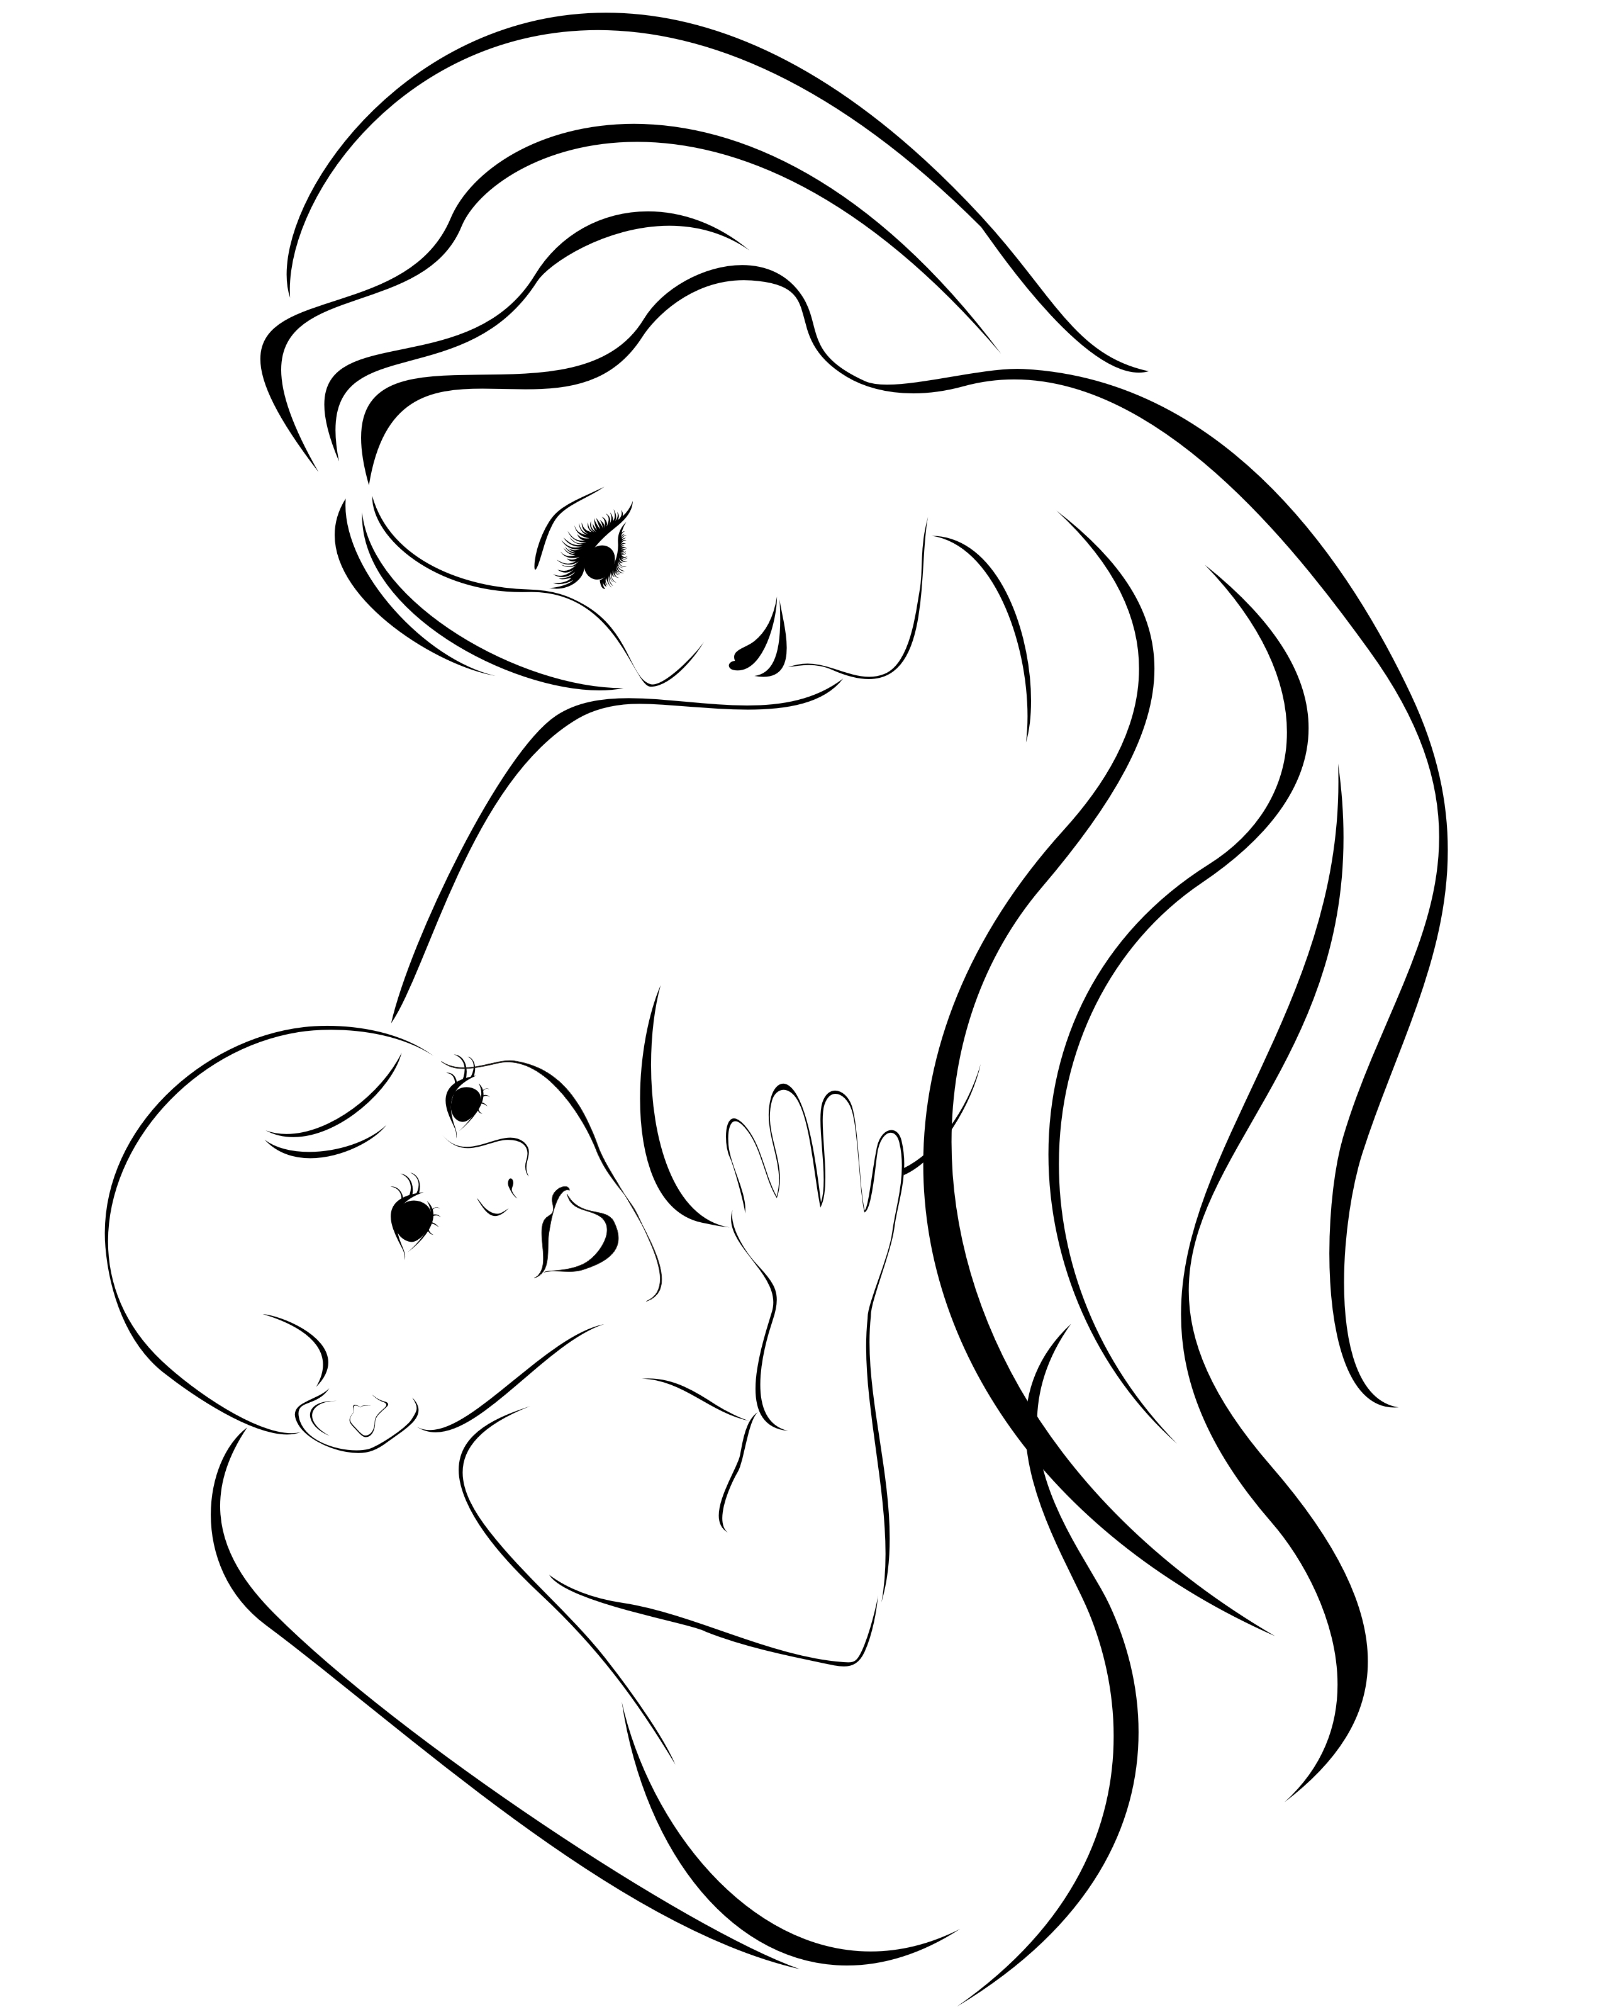

Source: http://mysimplemummysstuff.wordpress.com/2013/01/27/i-love-being-a-simple-mummy/

